CSCI2467
Lab 5
1. Create an Applet that will calculate the monthly cost of using an appliance.
Turn in:
- KilowattApplet.java
- KilowattApplet.html
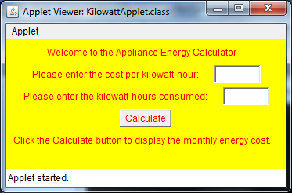
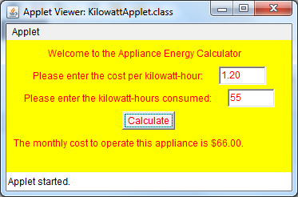

2. Currency Conversion (use swing components). Prompt a user to enter an amount in dollars. Output the conversions into euros, pounds and rubles. Use the following conversions: pound - .64; euro - .91; ruble – 61.73. Turn in:
- Currency.java
